TITLE OF EXTENDED ABSTRACT

Efficiently articulate the subject matter of the extended abstract within a maximum limit of 250 characters, incorporating the extended abstract title in 12-point boldface uppercase Time New Roman font. Align the title with the previously accepted abstract for consistency.

name surname ¹, name surname ², name surname ³…
¹ Affiliation Institution, Country, E-mail
² Affiliation Institution, Country, E-mail
² Affiliation Institution, Country, E-mail
(Authors’ names are set in 10 pt and in upper case. Affiliations are in 9 pt italics.)

Introduction
To enhance the overall clarity of the extended abstract adhere to the following chapter structure: Introduction, Methods, Results and Conclusion, as explicitly detailed in the subsequent text. Lower-level headings should not be employed. The extended abstract must not exceed 2 pages.

Formatting Guidelines:
- Chapter titles should be typed in 11 pt boldface.
- Chapter titles should have one line of space (11pt) above and none below.
- Do not number chapter titles.
- Utilize 11 pt "Times New Roman" font, justified, with single line spacing.
- Replicate the specified spacing for text and headings as elucidated and demonstrated in the text.
- New paragraphs should lack indentation but instead be separated by a line of space.
- Avoid incorporating footnotes.

The introductory section is expected to provide a short overview of the work's contextual background and articulate its specific objectives.

Methods
Concisely outline the employed methods/techniques, excluding the explication of their principles if readers can be directed to readily available references or standard texts.

A maximum of two tables or two figures can be included in the abstract. Figures and tables are not mandatory.

Figures may encompass illustrations or images in color or grayscale, requiring a minimum resolution of 300 dots per inch (dpi) for optimal readability. Sequentially number figures based on their occurrence in the text. Ensure accurate scaling of each figure to fit the available space, guaranteeing legibility. Maintain a minimum text size of 9 points on figures to facilitate easy readability.

Tables must be presented in an editable format, avoiding image formats. Sequentially number tables based on their order in the text, and position any table notes beneath the table body. Exercise restraint in table usage, ensuring that the data presented does not replicate results elaborated elsewhere in the article. Abstain from incorporating vertical rules. Tables should adhere to a consistent style, exemplified in Table 1. Additionally, refrain from dividing tables across two pages.

Figure and table captions are to be formatted in 10-point bold typeface, following the prescribed structure as indicated below.

Table 1. Caption heading for a table should be placed at the top and centered
Risk | Site Investigation | Technique | Design | Performance | Monitoring | Priority vector
Site investigation | 1/1 | ¼ | 1/1.5 | 1/2 | 1.5/1 | 0.109
Technique | 4/1 | 1/1 | 3/1 | 1.5/1 | 6/1 | 0.419
Design | 1/2.5 | 1/3 | 1/1 | 1/2 | 2/1 | 0.143
Performance | 1/2 | 1/1.5 | 2/1 | 1/1 | 3.5/1 | 0.258
Monitoring | 1/3 | 1/6 | 1/2 | 1/3.5 | 1/1 | 0.071
Notes: Notes should be given in Times New Roman, 9pt

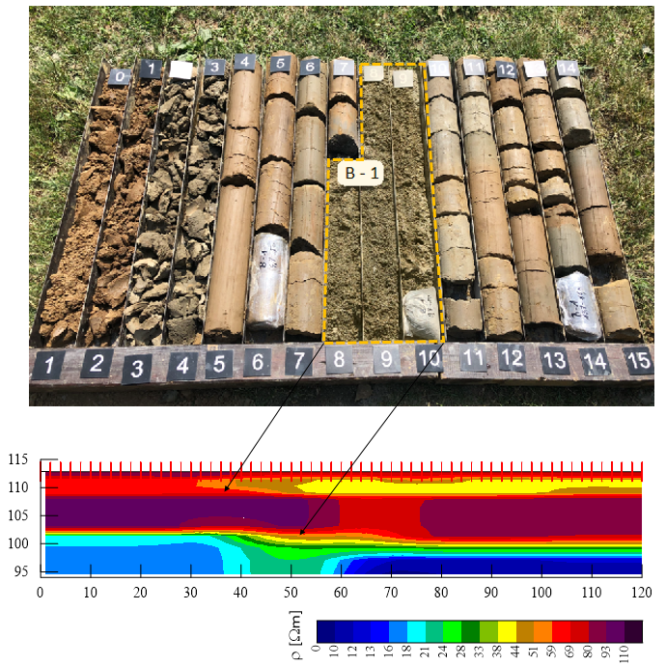

Figure 1. The caption heading for a figure should be placed below the figure, centered. All figures should be correctly positioned within your *docx file.

Results
This section is anticipated to deliver a clear presentation of the results, emphasizing discernible trends or notable observations.

Conclusion
This chapter is tasked with providing a concise explanation of the significance and implications inherent in the reported work.

References
The reference heading is to remain unnumbered. Author-utilized references are to be presented at the conclusion of the paper, without citation in footnotes. It is imperative to include all cited works in the reference list, ensuring alignment of dates and authors between the text and the reference list. References must furnish adequate details for reader retrieval (refer to formats below). All references in the paper must be cited, and the reference list should be organized alphabetically by the lead author's last name, incorporating all authors.

Examples of References
Barton, N. Rock Quality, Seismic Velocity, Attenuation and Anisotropy, UK & Netherlands, Taylor & Francis, 2006.
DINOloket (Data en Informatie van de Nederlandse Ondergrond Hoofdnavigatie). Available online: www.dinoloket.nl (accessed on 28 December 2021).
Goodman, R. E.; Shi, G. Block Theory and Its Application to Rock Engineering, New Jersey, Prentice Hall, 1985.
Hoek, E.; Marinos, P. A brief history of the development of the Hoek-Brown failure criterion. Soils and Rocks. 2007, 30, 85–92.
Karim, R. Modeling the Long Term Behavior of Soft Soils. Ph.D. Thesis, University of New South Wales, Canberra, Australia, 2011.
Kovacevic, M.S.; Bacic, M.; Gavin, K. Application of neural networks for the reliability design of a tunnel in karst rock mass. Canadian Geotechnical Journal. 2021, 58, 455–467.
Reale, C.; Gavin, K.; Libric, L.; Juric-Kacunic, D. Automatic classification of fine-grained soils using CPT measurements and Artificial Neural Networks. Advanced Engineering Informatics. 2018, 36, 207–215.
Vermeer, P.A.; Neher, H.P. A soft soil model that accounts for creep. In Proceedings of the International Symposium on Beyond 2000 in Computational Geotechnics, Amsterdam, The Netherlands, 18–20 March 1999; CRC Press: Amsterdam, The Netherlands, 1999

