Title of the paper (no more than 10 words)
1st Author’s Name and Surname¹, 2nd Author’s Name and Surname²,
…, nth Author’s Name and Surname^{n}
¹Full title of working place, working place full address (street, No, City, Zip-code, Country),
²Full title of working place, working place full address (street, No, City, Zip-code, Country),
^{n}Full title of working place, working place full address (street, No, City, Zip-code, Country),
E-mails: ¹……@...; ²……@...; ^{n}……@...
Abstract. The size of the abstract must have no more than 250 words. The abstract must summarize the major aspects of the entire manuscript, i.e. the purpose or the issues investigated; the experimental design and methods used; the major findings; a brief summary of the interpretations and conclusions. The abstract must be written without abbreviations.
Keywords: some general terms, some subject-specific terms. The keywords shall include 5–8 items

Introduction
To ensure a uniform format, authors must produce a PDF document that meets the formatting specifications outlined herein, including font sizes, margins, etc. All submitted articles should follow the sample.

Style and Format
Papers must be printed in a single column format as indicated. Margins should be 2.5 cm from left and right. Headers should be at 1.25 cm from top and the footer should be at 1.25 cm from the bottom of the page.

Fonts
Authors should use Times New Roman style fonts. Please be careful not to use nonstandard or unusual fonts. Including such fonts could cause problems when printing.
Headers and Footers should be in 9pt type. The title of the paper should be in 14pt bold type. The abstract should be in 10pt type. Main headings should be in 12pt bold type and secondary headings should be in 11pt bold type. The text and body of the paper should be in 11pt with a 6pt spacing after.

Title and Authors
The title appears near the top of the first page, centered. Authors' names should appear in the areas below the title of the paper in 12pt bold type. Authors' affiliations, complete addresses and electronic addresses should be in italics.

Abstract
The abstract appears at the beginning of the paper, indented 0.7 mm from the left and right margins and should be in 10pt type.

Headings and Sections
When necessary, headings should be used to separate major sections. All-level headings should be in 11pt bold type. Do not skip lines between paragraphs. All headings should be capitalized. After a heading, the first sentence should not be indented.
References to sections (as well as figures, tables, theorems and so on), should be capitalized, e.g ``In Section 4, we show that...''.

Acknowledgements
The acknowledgments section, if included, appears after the main body of the text and is headed ``Acknowledgments.'' This section should not be numbered. This section includes acknowledgment of contribution from associates and colleagues, financial support, and permission to publish.

Appendices
Appendices, if included, should follow the acknowledgments. Each appendix should be lettered, e.g., ``Appendix A''. If online appendices are submitted, they should not be included in the final manuscript (see below), although they may be referred to in the manuscript. They will be published online in separate files. The online appendices should be numbered and referred to as Online Appendix 1, Online Appendix 2, etc.

Tables
Tables should be inserted in proper places throughout the text. Do not group them together at the beginning of a page, nor at the bottom of the paper.
All tables should be numbered and they should appear as close as possible to their first reference in the main text. A table should not conclude a paragraph.
The table numbers (for example, Table 1) and inscriptions should appear in 9 pt font.
Table 1. Your title here. The table should be placed below the caption.
Beam No.
 | M,  kNm | ω,  m | G_{w},_{eff,exp}, MN/m² | G_{w,eff,call}, MN/m²
SA1 | 14.58 | 0.00535 | 587.9 | 603.8 | 0.974
SA2 | 15.23 | 0.00482 | 1080.0 | 1080.0 | 1.00
SC2 | 11.43 | 0.00483 | 276.0 | 270.0 | 1.02

Figures
Figures should be inserted in proper places throughout the text. Do not group them together at the beginning of a page, nor at the bottom of the paper. Number figures sequentially, e.g., Figure 1, and so on.
All figures should be numbered and mentioned in the main text, as close as possible to the first reference to them in the paper. A figure should not conclude a paragraph.
The figure number and caption should appear under the illustration. Captions, labels, and other text in illustrations should appear in 9pt font.
The numbers in the figures should be separated by dots (not by commas).
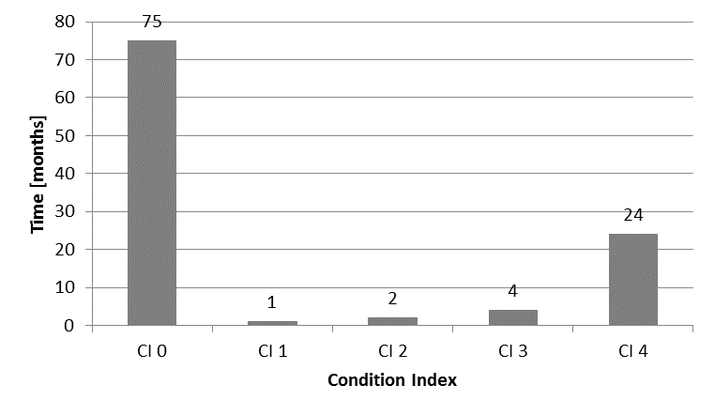
Fig. 1. Your title here
In case the Figure comprises several sub-figures, the caption should appear as follows:
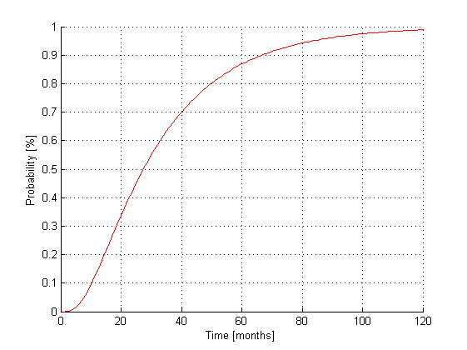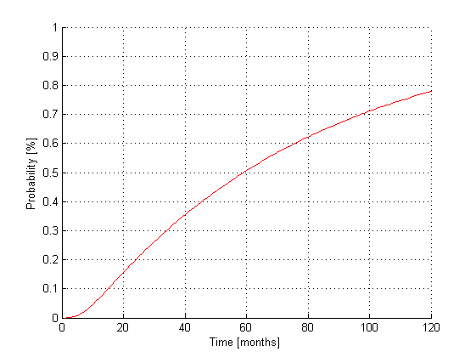
Fig. 2. Behaviour analysis:
a – faster evolution; b – slower evolution

Formulas and equations
Formulas, equations and their components presented in the text must be written using the Equation Editor (Fig. 3) or Mathtype.
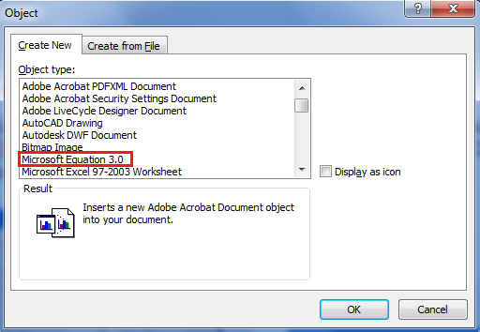
Fig. 3. Microsoft Equation
Main symbols ‒ Italic 10 pt type, the indexes ‒ 7 pt, sub-indexes ‒ 6 pt (Fig. 4). All the numerals, including index numbers, are presented in Regular type.
a) b)
Fig. 4. Equation Editor options (Times New Roman, 9 pt): a – styles; b – sizes
Matrices should appear in square brackets, vectors by 10pt bold-regular.
Formulas should follow the following format:
where a ‒ ……., units; b ‒ ……., units; c ‒……., units. All symbols must be explained in the order they appear.
Refer to equations in the text as “Eq (1)” or Eqs (2)‒(3).

Headers and Footers
On the odd numbered pages, the header of the page should be one present in this document. On the even pages, the header should be the title of the paper (shortened if necessary).
We encourage authors to use footnotes sparingly, especially since they may be difficult to read online. Footnotes should be numbered sequentially and should appear at the bottom of the page, as shown below.

References
The reference section should be labeled ``References'' and should appear at the end of the paper in natbib format. A sample list of references is given in Appendix A.
Citations within the text should include the author's last name and year, for example (Cheeseman, 1992). Append lower-case letters to the year in cases of ambiguity, as in (Cheeseman, 1993a). Multiple authors should be treated as follows: (Cheeseman & Englemore 1988) or (Englemore, Cheeseman & Buchanan, 1992). In the case of three or more authors, the citation can be shortened by referring only the first author, followed by ``et al.'', as in (Clancey et al., 1991). Multiple citations should be separated by a semi-colon, as in (Cheeseman, 1993a; Buntine, 1992). If two works have the same author or authors, the appropriate format is as follows: (Drummond 1990, 1991).
If the authors' names are mentioned in the text, the citation need only refer to the year, as in ``Cheeseman and Englemore (1988) showed that...''.
In general, you shouldn't have parenthetical statements embedded in parenthetical statements. Therefore, citations within parenthetical statements should not be embedded in parentheses. Use commas as separators instead. For instance, rather than ``(as shown by Bresina (1992))'' you should write ``(as shown by Bresina, 1992)''. Similarly, ``(e.g., (Bresina, 1992))'' should be ``(e.g., Bresina, 1992). Note that the natbib style file supports the inclusion of prefixes in citations.

Acknowledgements
Who helped, funded, etc.
- : Natbib Reference Examples
Any appendix comes before the references. The following formatting examples are intended to be illustrative, not exhaustive. If you are uncertain about the proper format for a reference, please contact the JMLR editors.
  - Book
Richard Bellman. Dynamic Programming. Princeton University Press, Princeton, New Jersey, 1957.
  - Edited Book
Robert R. Bush and William K. Estes, editors. Studies in Mathematical Learning Theory. Stanford University Press, Stanford, California, 1959.
  - Journal Article
Dana Angluin and Philip Laird. Learning from noisy examples. Machine Learning, 2(4):250-370, 1988.
  - Proceedings Paper
Charles W. Anderson. Strategy learning with multilayer connectionist representations. In Proceedings of the Fourth International Workshop on Machine Learning, pages 103-114, Ann Arbor, Michigan, 1987.
  - Technical Report
Andrew G. Barto. Connectionist learning for control. Technical Report 89-89, Department of Computer and Information Science, University of Massachusetts, Amherst, Massachusetts, 1989.
  - Dissertation or Thesis
Michael L. Littman. Algorithms for Sequential Decision Making. PhD thesis, Brown University, Providence, Rhode Island, 1996.
  - Forthcoming Publication
Stephen H. Muggleton. Statistical aspects of logic-based machine learning. ACM Transactions on Computational Logic, forthcoming.
  - URL
COST TU1406. http://www.tu1406.eu
In general, try to avoid giving URLs. If you must, make sure they are stable. There are, unfortunately, many broken URLs in the literature. Consider creating a permanent URL at http://www.purl.org (You can update these indirect pointers at any time. Be sure to designate in your will who will be responsible for your PURLs after you retire).

References
Patrick W. Daly. Natural sciences citations and references. Available online at ftp://ftp.freesoftware.com/pub/tex/ctan/macros/contrib/supported/natbib, 1997.
Donald E. Knuth, Tracy L. Larrabee, and Paul M. Roberts. Mathematical Writing. Mathematical Association of America, Washington, D.C., 1989. ISBN 0-88385-063-X.
Mary Claire Van Leunen. A Handbook for Scholars. Oxford University Press, 1992.
Steven Minton, Martha Del Alto, and Helen Stewart. Instructions for formatting JAIR articles. Available electronically via http://www.jair.org/submission-info.html, 1999.

A footnote should appear like this. Please ensure that your footnotes are complete, fully punctuated sentences.

